ATL
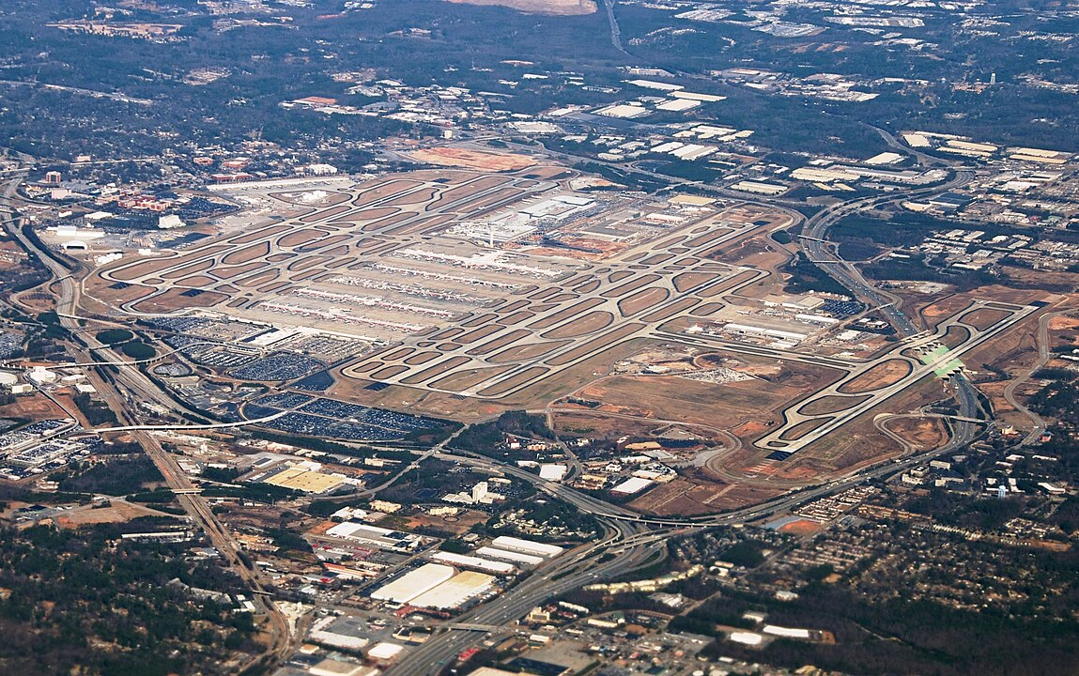An aerial view of Hartsfield-Jackson International Airport, by Craig Butz

Problem to Solve
Hartsfield-Jackson International Airport, perhaps better known as “ATL” for its IATA airport code, has been the busiest airport in the world since 1998. Located in Atlanta, Georgia in the United States, ATL served 93.7 million passengers in 2022. Maybe you were one of them!
Suppose you’ve just been hired to help ATL re-design their database system. In a file called schema.sql in a folder called atl, write a set of SQL statements to design a database with which Hartsfield-Jackson could keep track of its passengers and their flights.
Wondering how to create a folder and file yourself?

Specification
Your task at hand is to create a SQLite database for ATL from scratch, as by writing a set of CREATE TABLEstatements in a schema.sql file. The implementation details are up to you, though you should minimally ensure your database meets the airport’s requirements and that it can represent the given sample data.

Requirements
To understand ATL’s requirements for their database, you sat down to have a conversation with the Assistant General Manager for IT Operations.

Passengers
When it comes to our passengers, we just need to have the essentials in line: the first name, last name, and age. That’s all we need to know—nothing more.

Check-Ins
When passengers arrive at ATL, they’ll often “check in” to their flights. That’s them telling us they’re here and all set to board. We’d like to keep a tidy log of such moments. And what would we need to log, you ask? Well, here’s what we need:
- The exact date and time at which our passenger checked in
- The flight they are checking in for, of course. Can’t lose track of where they’re headed, now can we?

Airlines
ATL’s a hub for many domestic and international airlines: names like Delta, British Airways, Air France, Korean Air, and Turkish Airlines. The list goes on. So here’s what we track:
- The name of the airline
- The “concourse” or, shall I say, the section of our airport where the airline operates. We have 7 concourses: A, B, C, D, E, F, and T.

Flights
We serve as many as 1,000 flights daily. To ensure that our passengers are never left wondering, we need to give them all the critical details about their flight. Here’s what we’d like to store:
- The flight number. For example, “900”. Just know that we sometimes re-use flight numbers.
- The airline operating the flight. You can keep it simple and assume one flight is operated by one airline.
- The code of the airport they’re departing from. For example, “ATL” or “BOS”.
- The code of the airport they’re heading to
- The expected departure date and time (to the minute, of course!)
- The expected arrival date and time, to the very same accuracy

Sample Data
Your database should be able to represent…
- A passenger, Amelia Earhart, who is 39 years old
- An airline, Delta, which operates out of concourses A, B, C, D, and T
- A flight, Delta Flight 300, which is expected to depart from ATL on August 3rd, 2023 at 6:46 PM and arrive at BOS on August 3rd, 2023 at 9:09 PM
- A check-in for Amelia Earhart, for Delta Flight 300, on August 3rd, 2023 at 3:03 PM

Usage
To create a database from your schema, within your atl folder, type
sqlite3 atl.db
The above will create an empty SQLite database called atl.db.
Then, in the sqlite3 prompt, type
.read schema.sql
to read the statements from schema.sql.
Recall you can use DROP TABLE tablename, where tablename is the name of your table, to delete a table from your database.

